**MH REPORT SYSTEM**

**User Manual**

**Revision 1.0**

**2016/07/09**

**Table of Contents**

1. **Installation Guide**
2. **Getting Started**
   1. **Change Settings Window**
   2. **JPI Team File**
3. **Main Menu**
   1. **MH Data Report**
   2. **Change Setting**
   3. **Draw Graph**
   4. **Exit**
4. **Report Overview**
5. **Error Basic Troubleshooting**
6. **Installation Guide**

Open the folder to where the MH Report System Installer is located and click then wait for the system to complete verification.

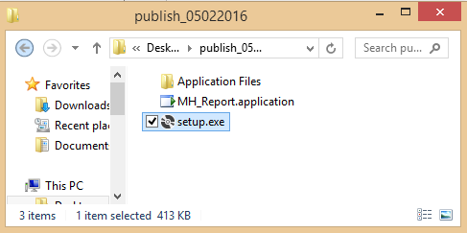

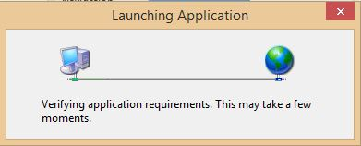



Click the button and then wait for the installation to complete.

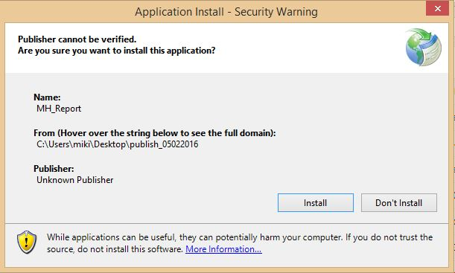

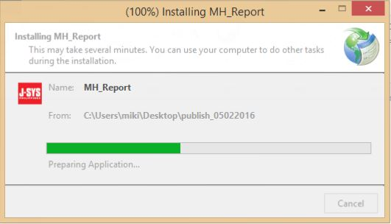

1. **Getting Started**
   1. **Change Settings**
2. On initial access, a warning message will pop up to request for settings configuration.

Click to go to the main menu.

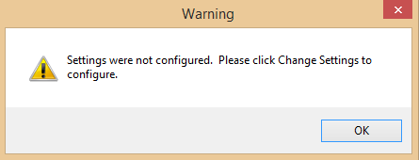



1. On the Main menu, click the button to go to the Settings Menu.

MH Data Report button will not be enabled until the settings are successfully configured.

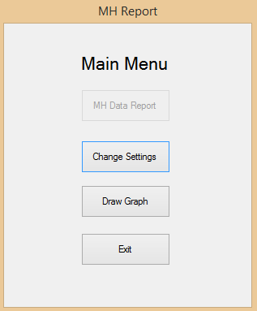

1. Click on the Settings Menu.

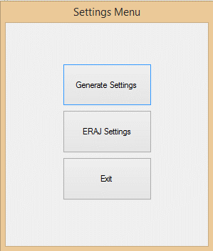

1. On the Change Settings window, click to select the path for the Source Folder and the Output Folder. Source Folder is the location of the timesheets. Output Folder is the location where the summary of timesheet will be saved.

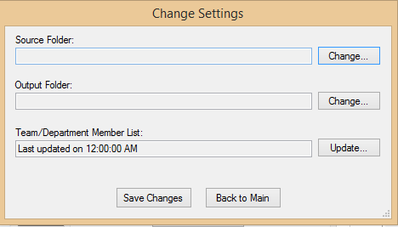



1. Select the location of the file then click

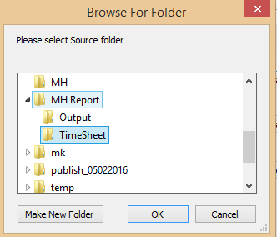

1. The selected path will be displayed in the textbox.

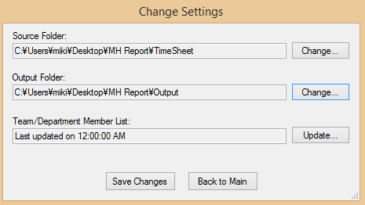

1. The Team/Department Member List displays the date the JPI Team List Excel file was last updated. Initially it displays “Last updated on 12:00:00 AM”. There is an excel file provided for updating the team lists. Click the button to set the Team/Department Member List.

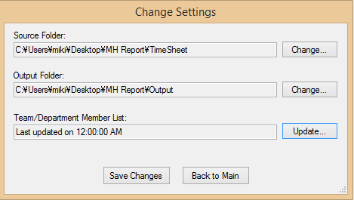



1. Select the Excel file that contains the list of teams/members then click

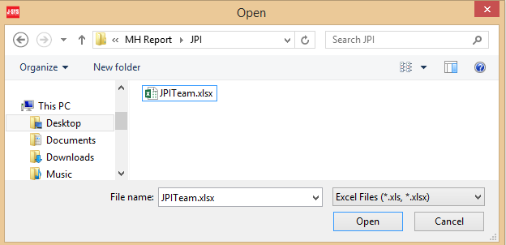

1. The selected Excel file name will be displayed. Click  to save all settings.

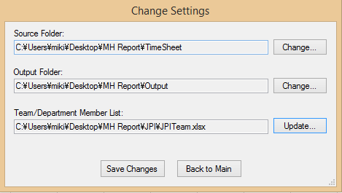

1. Wait until the configuration has been saved.

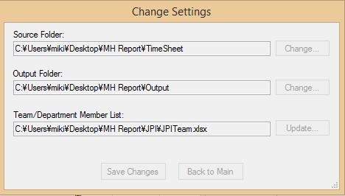

1. Confirmation message will be displayed once settings were successfully updated. Click 

to close the Change Settings window.

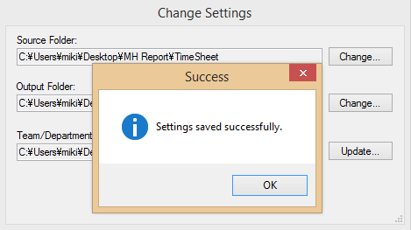

1. The Latest Updated Data and Time of the settings will be displayed.

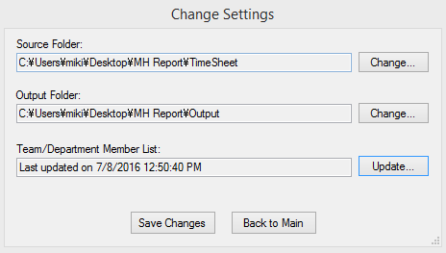

1. Error message will be displayed if there were any issues.

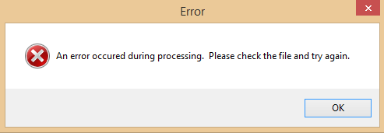

* 1. **JPI Team File**

Excel File that contains the list of department/team names and each respective members. Note to always use the leftmost sheet of leftmost sheet of the excel file and not to leave any blank rows or columns in between data.

Below are instructions on how to create the JPI Team File.

1. List the team names horizontally from left to right starting at row1 and column A as shown below. Place an ‘”end” after the last item on the team names.

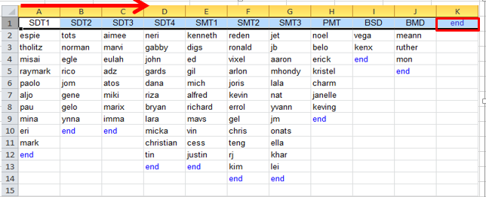

1. List the members’ names per team vertically from top to bottom starting at row 2 as shown below. Place an “end” after the last item on the list.

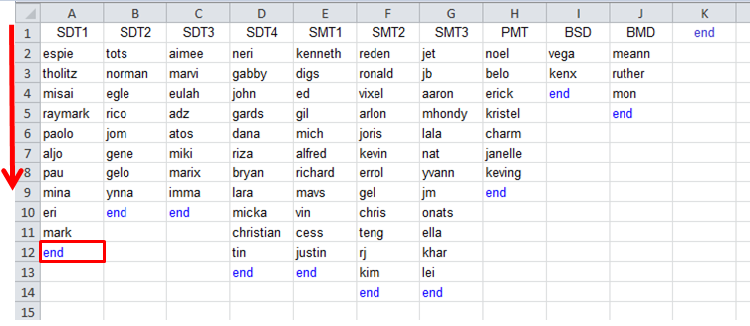

1. Use the first and rightmost sheet to create the file.

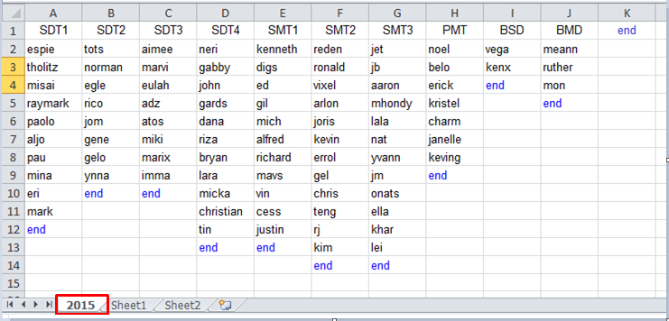

1. Avoid leaving spaces in between items.

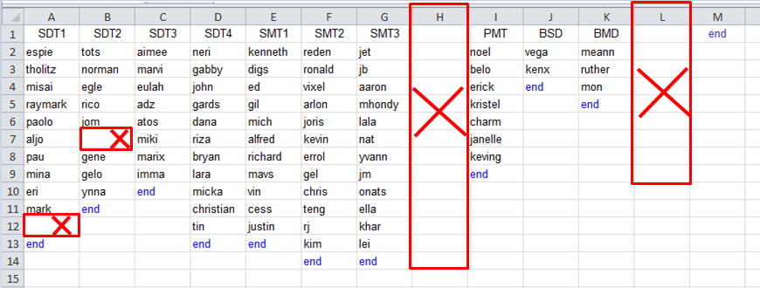

1. **Main Menu**
   1. **MH Data Report**

MH Data Report is the menu option to generate the summary of the timesheets. There is also an option to draw an ERAJ graph from the summarized timesheets. Below are instructions on how to generate this report.



* + - 1. Click to proceed.

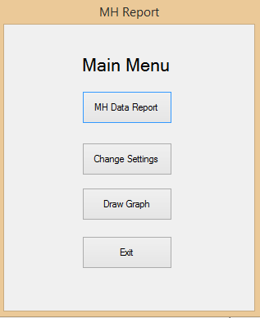

* + - 1. Select the year from the dropdown.

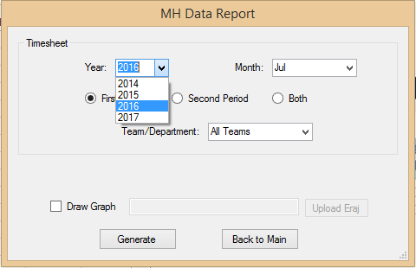

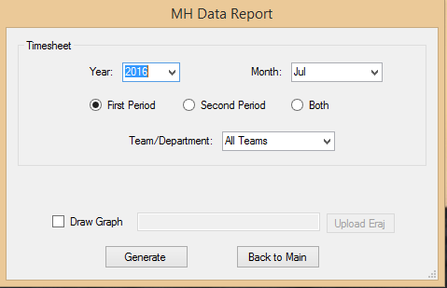

* + - 1. Select the month form the dropdown.

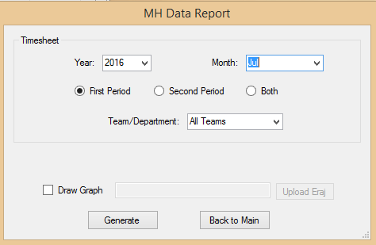

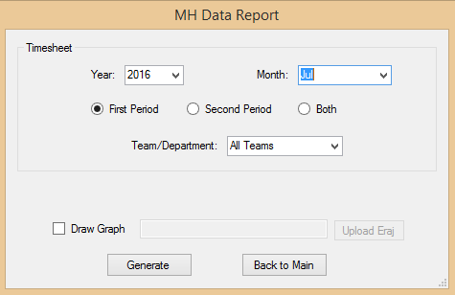

* + - 1. Choose the timesheet period.

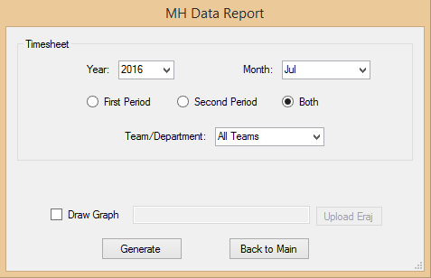

* + - 1. Select the team/department from the dropdown list.

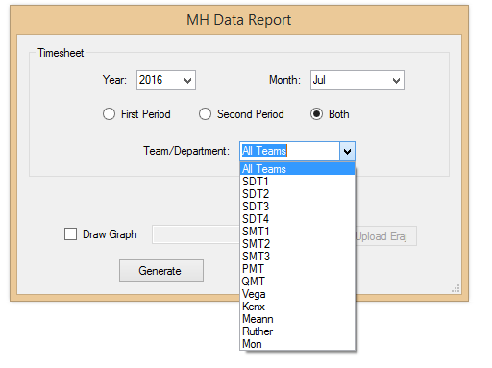

* + - 1. (Optional) To generate an ERAJ graph, check on the Draw Graph box and click .

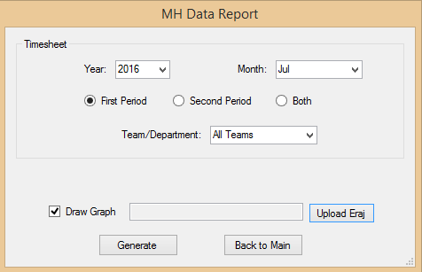

Select the ERAJ Excel file to use and click . Users have the option to use a blank ERAJ File or an ERAJ File with previous months’ graph. A blank ERAJ file will only graph one month while an ERAJ file with previous records will show the trend from the previous months to the current month.

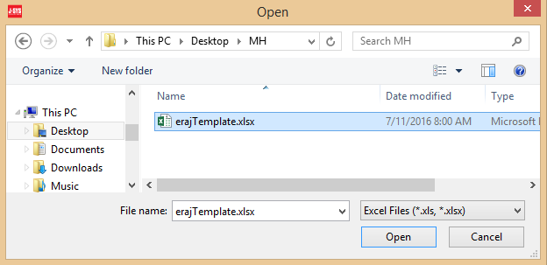

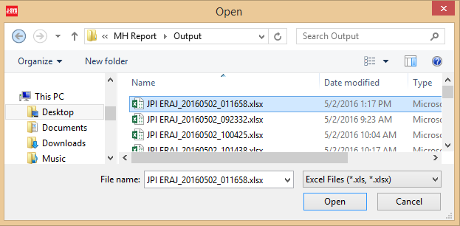

* + - 1. Click  to start processing.



* + - 1. Wait until the MH Data Report has been generated.

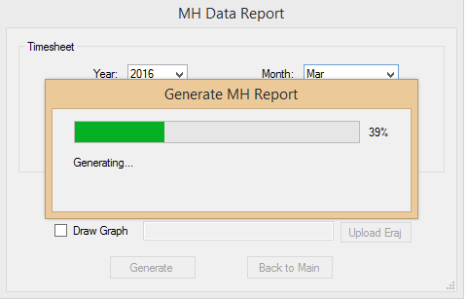

* + - 1. Confirmation message will be displayed once MH Data Report was successfully generated. Click  to return to MH Data Report window.

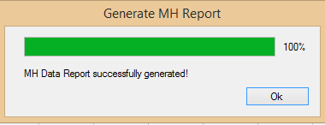

* + - 1. Confirmation message will also show if the MH Data report was generated with error. Click  to return to MH Data Report window. Refer to error basic troubleshooting for added information regarding the possible causes of these errors.

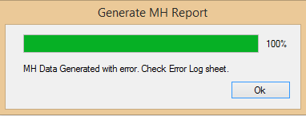

* + - 1. To access the MH Report generated, go to the output folder set on the Change Settings Window. The file name format is set as “”MH Report YYYYMMDD_HHMMSS.xlsx”.

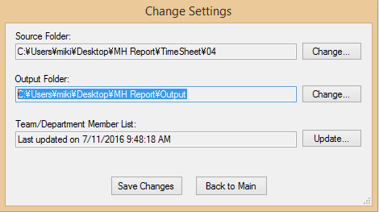

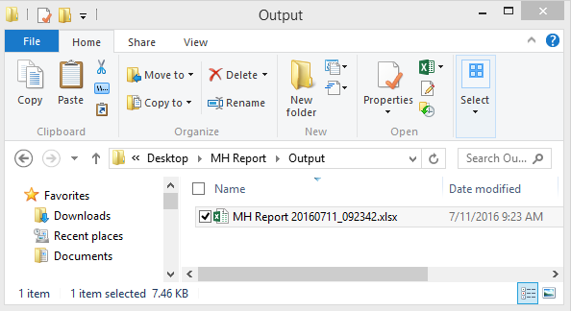

* 1. **Change Settings**

The Change Settings Menu allows users to update previously set files, folder directories as well as the JPI Team/Department List. It has three sub menus, Generate Settings, ERAJ Settings and Exit. Below are each of these functions and steps on how to use them.

* + 1. **Generate Settings**

The Generate Settings window is where the file path of Source Folder of and the Output folder are changed. The Team/Department Member List can also be updated on this window.

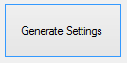

1. Click from the Settings Menu window.

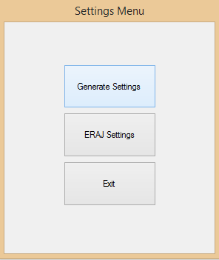



1. On the Change Settings window, click to select the path for the Source Folder and the Output Folder. Source Folder is the location of the timesheets. Output Folder is the location where the summary of timesheet will be saved.

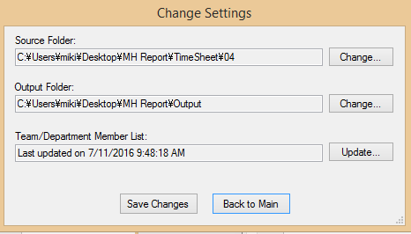

1. Select the location of the file then click



1. The updated path will be displayed in the textbox.

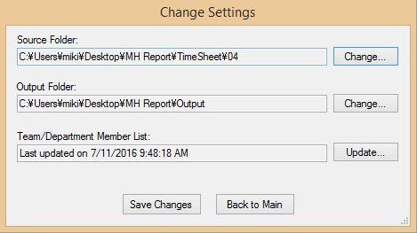

1. If there are changes on the team/department members, update first the excel file containing the new team members list. Then click to upload the new file.



1. Select the Excel file that contains the list of teams/members then click



1. The selected Excel file name will be displayed. Click  to save all settings.



1. Wait until the configuration has been saved.



1. Confirmation message will be displayed once settings were successfully updated. Click 

to close the Change Settings window.



1. The Latest Updated Data and Time of the settings will be displayed.



1. Error message will be displayed if there were any issues. Refer to error basic troubleshooting for added details.



1. Click to go back to main menu window.

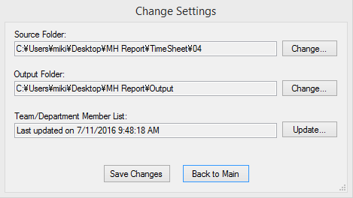

* + 1. **ERAJ Settings**

ERAJ Setting menu is used to upload the ERAJ template to be used for drawing the graph.

ERAJ template file is provided. Below are instructions on process this set up.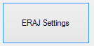

1. Click to proceed.

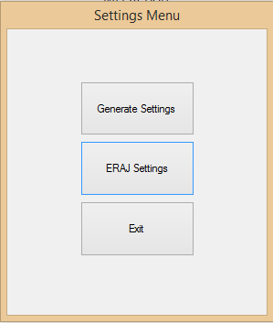

1. Click the  button.

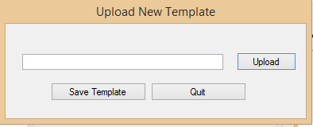

1. Select the ERAJ Template file provided and Click 

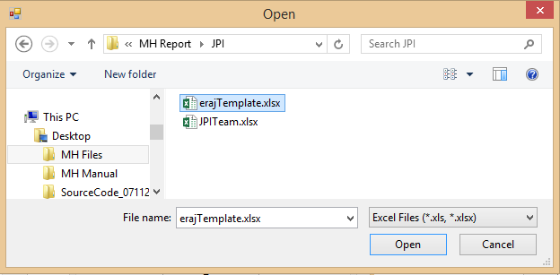

1. Click  and wait for the process to complete.

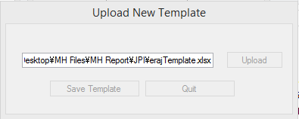

1. Configuration message will be displayed once settings were successfully updated. Click  to close the Change Settings window.



1. Error message will be displayed if there were any issues.



1. Click quit to go back to the main menu.

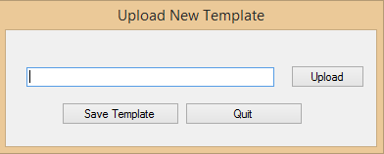

* + 1. **Exit**

Click 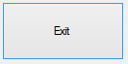 to go back to the main menu.

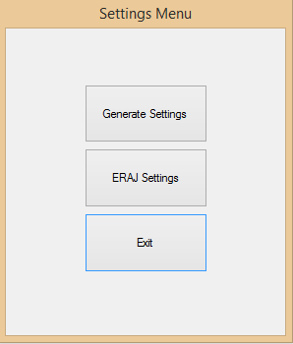

* 1. **Draw Graph**

Draw Graph is the menu option to graph ERAJ data. Users have the option to use a blank ERAJ File or an ERAJ File with previous months’ graph. A blank ERAJ file will only graph one month while an ERAJ file with previous records will show the trend from the previous months to the current month. Below are instructions on how to process this.

* + - 1. Click  from the main menu.

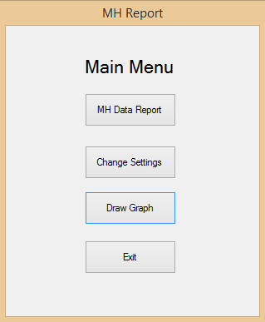

* + - 1. On the Draw ERAJ window, click to set the path for the Team Totals Source and ERAJ Template Source. The Team Totals Source is the location where the summarized timesheet file is saved while the ERAJ Template Source is the location of the ERAJ template file.

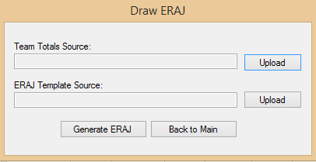

* + - 1. Select the Excel file that has the data to be used to graph the ERAJ and click . This is the output file generated from the MH Data Report.

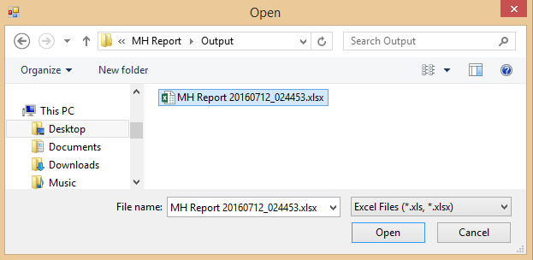

* + - 1. Select the ERAJ file to be used as template and click . This template file will be copied to create an output file using the data from the summarized timesheets. This will graph the ERAJ for that month. If the template used contains the ERAJ graph from previous months, it will show the ERAJ trend.

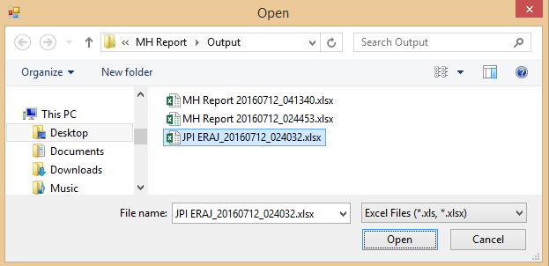

* + - 1. The selected file sources will be displayed. Click .

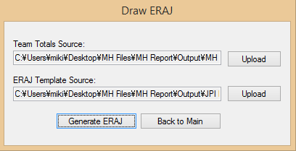

* + - 1. Wait for the process to be completed.

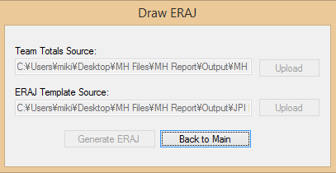

* + - 1. Confirmation message will be displayed once ERAJ has been successfully generated. Click  to go back to the Draw ERAJ window.

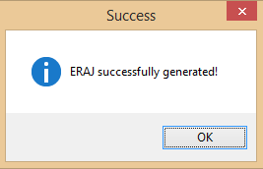

* + - 1. Error message will be displayed if there were any issues.

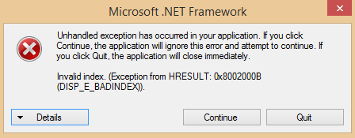

* + - 1. Click  to return to the MH Report Main Menu window.

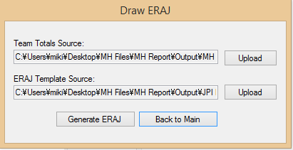

* 1. **Exit**

Click  to close the MH Report System.

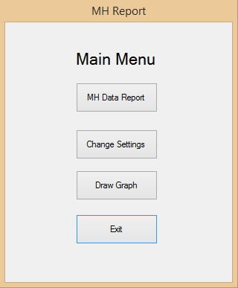

1. **Sample Report and Overview**
   1. **MH Report**

The MH Report is the report generated from the MH Data Report menu. This summarizes the timesheets for a selected month. The report can be generated for all teams or a specific team. It can also be set to summarize the 1st period, 2nd period or both periods of the timesheet. Below is an overview of the sheets on the MH report.

* + - 1. Summary

This is the main sheet of the MH Report and that shows the man hour summarize per team, per type of job code as well as the month’s grand total. The first cell also show the particular Month of the timesheet.

1. Sample of summary for MH Report for all teams.

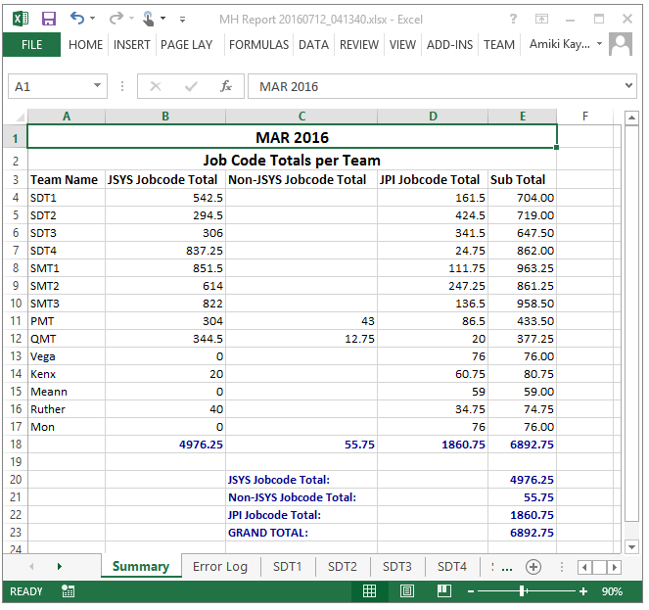

1. Sample summary for MH Report for a specific team.

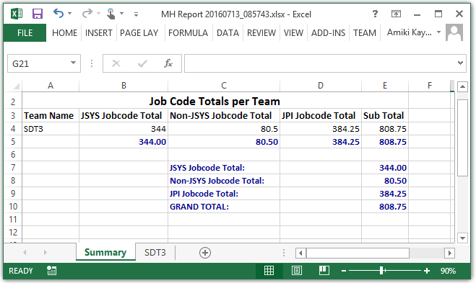

* + - 1. Error Log

If there were any issues on generating the MH report, the error log sheet will be created. This sheet will show the specific timesheet that has issue. Refer to Error basic troubleshooting for added details.

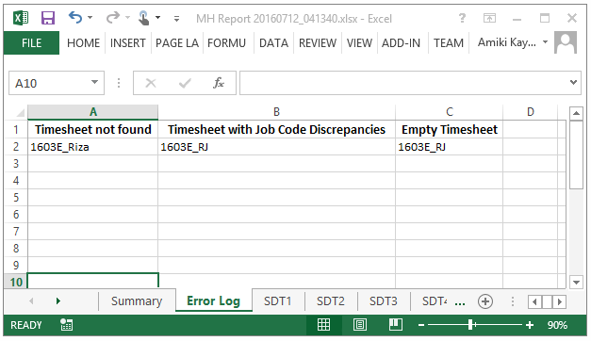

* + - 1. JPI ERAJ 2016 Team Names

If the Draw Graph checkbox was checked, an ERAJ sheet will be created. Based on the MH Report generated, the summarized data will be plotted and a graph will be created for that month.

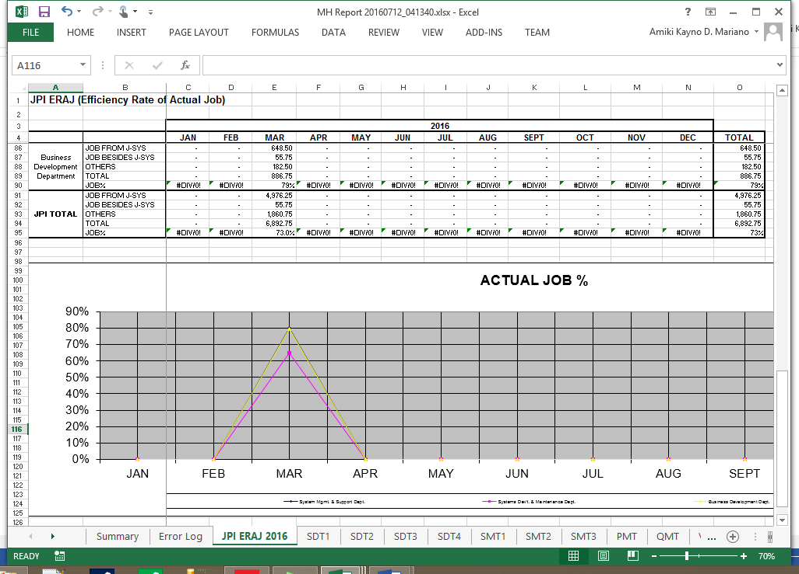

* + - 1. Team Names

The next set of sheets will show the summary per team and/or per manager.

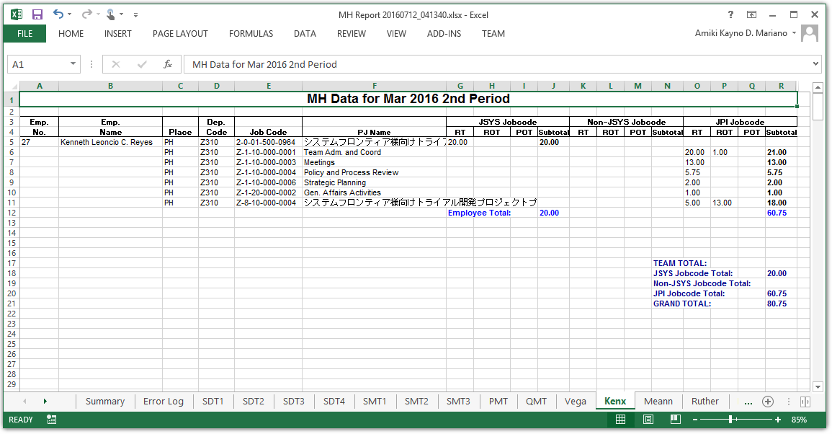

* 1. **ERAJ Graph**

The JPI ERAJ Report is generated from the Draw Graph menu. This would graph the ERAJ for that month. If the ERAJ template file used contains a previous months’ ERAJ, the graph would show the ERAJ trend.

* + - 1. ERAJ Sample

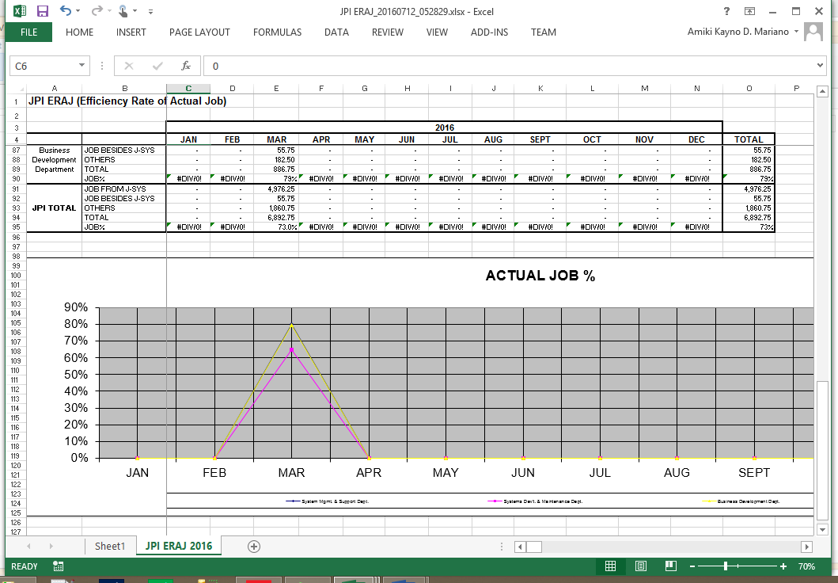

* + - 1. ERAJ Sample with previous months’ graph.

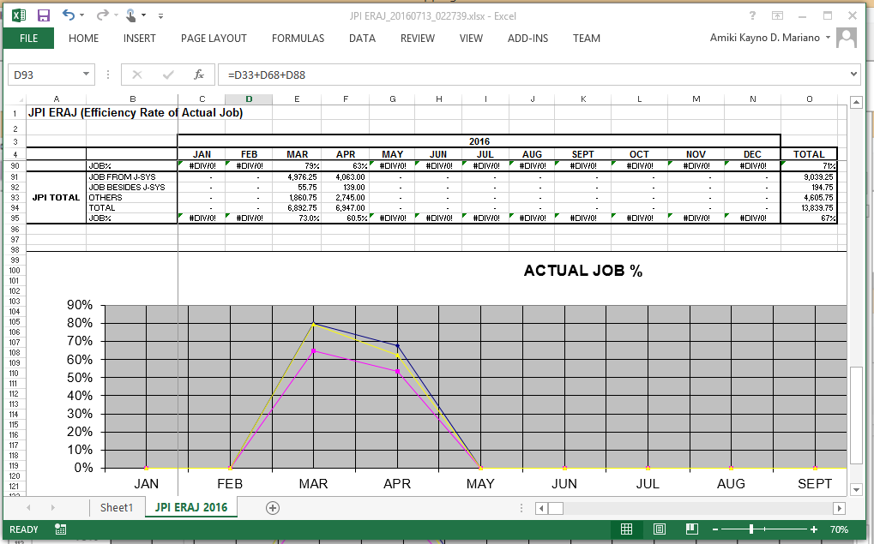

1. **Error Basic Troubleshooting**
   1. **Change Settings**
      * 1. The common cause of the message error below is on the Team/Department Member List. Make sure that the JPI team file to be used follows the JPI team file.



* 1. **MH Data Report**



There are several why the MH Data will be generated with an error. The report has an Error Log sheet which shows what particular timesheet which encountered an error. Error Refer to the list below for added information.

* + - 1. Timesheet not found.

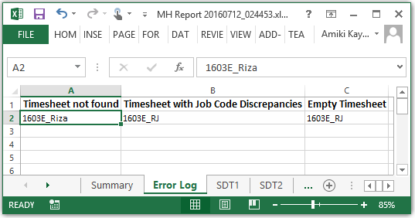

The system will find all the members’ timesheet as listed on the JPI team file. If it was not able to locate the timesheet, it will be listed on the Timesheet not found column. Kindly make sure of the following to prevent this error.

1. The filename is in the correct format. (YYMMB_Nickname or YYMME_Nickname)
2. Make sure that the JPI team list file is updated during team re-organization.
3. The Source Folder for the timesheet on Change Setting window is correct.
   * + 1. Timesheet with Job Code Discrepancies and Empty Timesheet

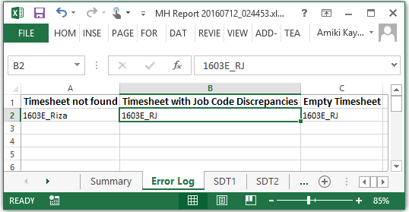

If there are discrepancies on the job code data then it member’s timesheet will be listed on the Timesheet with Job Code Discrepancies. The timesheet may not also be included on the total MH ad will be listed under the Empty Timesheet Column. Make sure that the timesheet submitted are correct and follows the JPI ruling on how to create timesheet.

* 1. **Draw ERAJ**

This error is caused when the system cannot generate a graph due to incorrect template file. Make sure to use the ERAJ template file provided.

